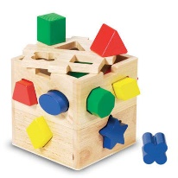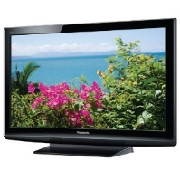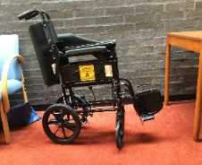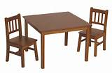

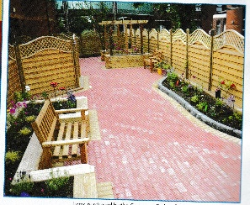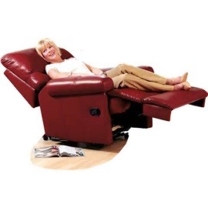

Governor

Patient Experience Charitable Fund
Lancashire Teaching Hospitals NHS Foundation Trust Charity
Charity Number: 1051194
All funds collected go towards various departments across Chorley and South Ribble and Royal Preston Hospitals. The purpose of the fund is:-
- To help purchase non clinical items.
- To support improvements to enhance the experience of both patients and visitors in all areas.
Trust staff, patients and the general public are encouraged to apply for funding from the charitable fund and are asked to complete and submit the application form.
All applications received will be evaluated and awarded against a set criteria by members of the Governor Patient Experience Group.
To submit an application please complete the attached form or Trust staff can access the application form on the Trust Intranet,
Please email the completed application form to:- PatientExperienceCharity@lthtr.nhs.uk
OR return to:-
Governor Postbox C/o Membership Office, Royal Preston Hospital, Sharoe Green Lane, Fulwood, Preston, PR2 9HR

Beneficiaries of the Governors Charitable Fund
Since its launch, the fund has contributed towards a range of items to benefit patients in the two hospitals in Chorley and Preston.

Examples of items purchased so far include:

- Toys and equipment for the children’s areas in the Accident and Emergency Department at Preston and Chorley.

- Televisions in various in-patient and out-patient areas.

- Wii Fit consoles to aid rehabilitation of physiotherapy patients.

- Furniture, chairs and toys for the play area in the maternity unit at Chorley & South Ribble Hospital

- Armchairs and footstools for the therapy treatment area in the Psychology Department
- ‘Afternoon Tea’ sessions in Dementia and Oncology wards
- Activity blankets, dolls and memory boxes for dementia patients
- Christmas trees, inside and outside on both sites
- Contributed towards the garden area outside the Rookwood wards at Chorley Hospital.

- TV/DVD for children and adults when they are being scanned.

Governor Patient Experience Charity Fund

Application Form

Please complete the following sections, providing as much detail as possible:

STAFF Application

Full name and job title
Telephone Number
Email address
Department and site (i.e.RPH/CDH)

PATIENT / PUBLIC Application

Full name and address
Telephone Number
Email address

Please provide a full description of the item(s), which you are requesting funding for. If approved, a supplier for your requested item will be sourced by the procurement team, therefore as much detail as possible (e.g. TV screen size etc./photograph/product information) would be helpful in ensuring the right item is identified for you. Also include an estimated cost inclusive of VAT. Please note that there is a limit per item and may be subject to financial capping:

Description of goods requested:-
Please briefly outline how you feel the purchase of this item will improve the experience of patients, carers and visitors who use the hospitals services:

If you are a member of staff all bids must be discussed and agreed with your General Manager. Please provide the details of this person:-
Full name and job title
Signature
Telephone Number
Email address

Please email the completed form to:-PatientExperienceCharity@lthtr.nhs.uk
OR return to:-
Governor Postbox C/o Membership Office, Royal Preston Hospital, Sharoe Green Lane, Fulwood, Preston, PR2 9HR

